# Installing Windows Subsystem for Linux

Open the Start Menu and type “windows features”.

Click on “Turn Windows features on or off”

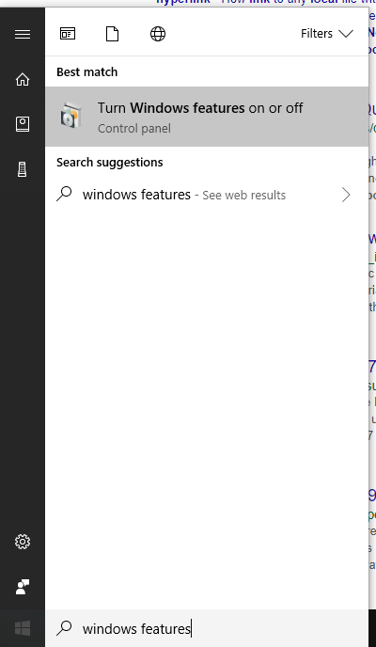This will open a window that looks like this (below). Scroll down and enable the check box next to “Windows Subsystem for Linux”.

Click “OK”. You might need to restart.

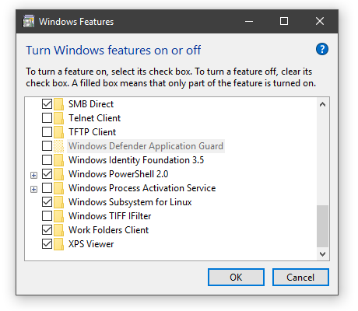

Now open the Window Stores and download ‘Ubuntu’. After it installs, you should be able to open Bash in any folder by typing ‘bash’ in the address bar and pressing Enter. (There are other ways to launch Bash from the start menu, but this is the most convenient).

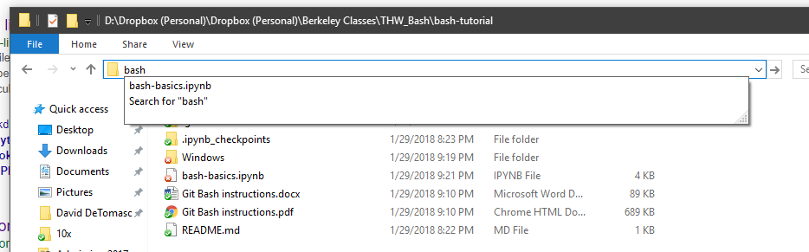

And your terminal window opens!

